Rui Tao
CSYE 7270
2025-12-8
Pedagogical Report
Teaching Behavior Tree AI in Unreal Engine 5
- Teaching Philosophy.
Target Audience:
This guide is designed for beginner Unreal Engine users who possess foundational knowledge of third-person templates but have limited exposure to AI systems. Participants should have a basic understanding of Blueprints, though they may not yet be familiar with behavior trees or AI perception systems.

Learning Objectives:
After this lesson, students will be able to:
Explain the purpose and structure of Behavior Trees and Blackboards
Configure AI Navigation
Build an autonomous NPC that patrols in the specific area
Debug decision-making flow using UE5

Rationale:
Game artificial intelligence is one of the most compelling components of interactive entertainment.
Behavior trees provide:
Modular decision logic
Visual debugging workflows
Designer-friendly scalability

- Concept Deep Dive
Foundations:
Behavior tree is a kind of hierarchical decision system composed of the components: Root, Composite, Decorator, Task, and Service. Their purposes are to entry point, select or sequence behaviors, enable/disable behaviors via conditions, executable actions, and continuous sensing and updates. Also, blackboard stores shared runtime variables such as location or target.

Game Design Connection:
Patrol interactions achieve the core objectives of player experience
- Autonomy: NPCs react to player actions
- Immersion: The game world presents a vibrant and responsive state
Thus, AI design not only supports functionality but also aligns with players' actual gameplay needs and experiences.

- Implementation Analysis
System Structure
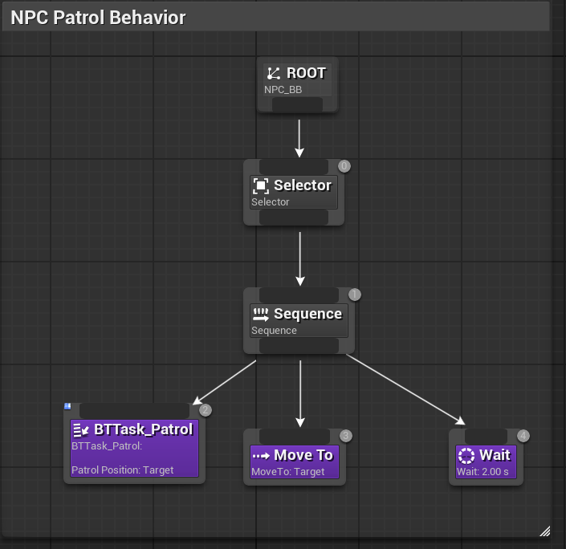
Major Modules:
Component | Role
BP_NPC | Character movement & animation
NPC_AIControl | Perception + BT execution
NPC_AI | Behavior Tree
BTTask_Patrol | Random point selection

Performance
Advantages:
- Low CPU overhead
- Minimal memory footprint
- Navigation mesh ensures efficient path planning
Scalability
You can add player pursuit behaviors, can add attack behaviors, can add various different NPCs, can reuse behavior trees.

- Assessment & Effectiveness
Validation Criteria
The learning outcomes will be measured through: Behavior trees ensure NPCs execute patrols correctly, debugging tools for interpreting states, Students added an additional behavior.

Expected Challenges
NPC is not moving, Blackboard values not updating, Execution jumps unexpectedly

AI Citation
ChatGPT

MIT License

Copyright (c) 2025 Rui Tao

Permission is hereby granted, free of charge, to any person obtaining a copy
of this software and associated documentation files (the "Software"), to deal
in the Software without restriction, including without limitation the rights
to use, copy, modify, merge, publish, distribute, sublicense, and/or sell
copies of the Software, and to permit persons to whom the Software is
furnished to do so, subject to the following conditions:

The above copyright notice and this permission notice shall be included in all
copies or substantial portions of the Software.

